Terrain Tiles And their Corresponding Terrain Types

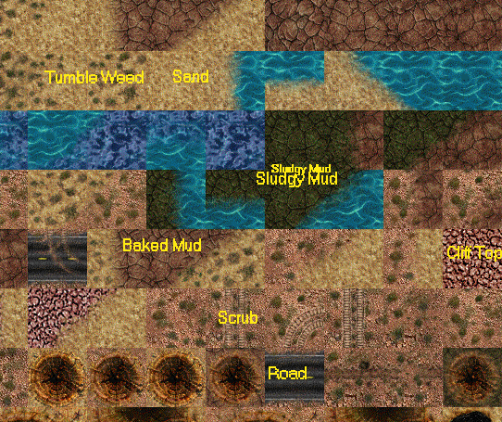
Types Are :-

For each different terrain tile , we should have a corresponding terrain type !

The terrain types should be ( and will be called the following ) :

Terrain Tile Terrain Type

Tumble Weed TumbleWeed
Sand Sand
Sludgy Mud SludgyMud
Baked Mud BakedMud
Scrub Scrub
Road Road

Cliff Top CliffTop – if used in final maps ( or demo ! )

